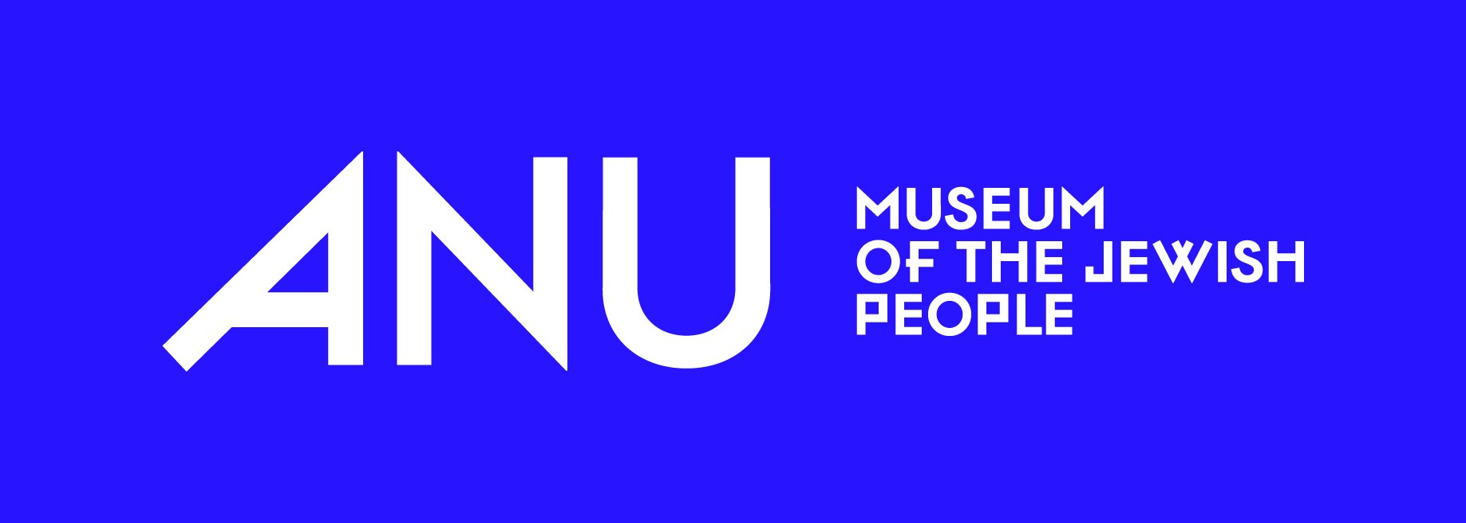
Jewish Love Languages
Reading objects, buildings, and sites through the lens of love — to connect visitors with Jewish peoplehood across time and space.
⏱ 45–60 min · 👥 In-person workshop · 🌍 EDJC 2026 · 🎯 Cultural heritage educators

LEARNING OBJECTIVES

By the end of this workshop, participants will be able to:
- Define Gary Chapman's five love languages and explain how they apply beyond personal relationships to families, communities, and peoples.
- Identify the six pillars of Jewish Peoplehood and connect them to the four levels of Jewish connectivity (individual, family, community, people).
- Analyze a Jewish object, building, or site using the love languages framework — identifying which love language(s) it expresses and at which level(s) it operates.
- Apply the love languages lens to their own organization's collection or programming for the European Days of Jewish Culture.

MATERIALS NEEDED

- Printed or projected overview of the 5 love languages
- Printed or projected diagram of the 4 levels of connectivity
- Images of 3–4 Jewish objects (e.g., a ketubah, a challah cover, a gartel, a mezuzah) for the small-group activity
- Images of a historic synagogue and a Jewish cemetery for the case study
- Sticky notes or index cards — one per participant
- Pens / markers
- Timer or phone for facilitator
- Optional: physical objects from your own collection
- ANU Databases to search for images to use throughout the workshop: dbs.anumuseum.org.il.

WORKSHOP FLOW

0–5 min  Opening | INTRODUCTION  Welcome & Workshop Norms  Welcome participants and set expectations: this is an interactive workshop — sharing, asking questions, and thinking aloud is encouraged. Remind participants to keep a running question in mind throughout:  “How can I bring this to my organization’s European Days of Jewish Culture?”
5–10 min  Warm-up | ✦ ACTIVITY 1 — OPENING REFLECTION  The Object That Carries More Than It Shows  Instructions:  - Ask participants to think of one object — from their own family or a community they belong to — that carries more love or meaning than its exterior suggests.  - Give 1 minute of silent reflection, then invite 2–3 participants to share briefly (30 seconds each).  - Facilitator bridges: “This tension between surface and meaning is exactly what we’re exploring today.”  Materials: None needed — this is a verbal reflection.
10–22 min  Content | CONCEPT INPUT  The Framework: Love Languages Meets Jewish Peoplehood  Part A — The 5 Love Languages (4 min): Introduce Chapman’s framework. Display each language with a definition and one Jewish-object example:  - Words of Affirmation — e.g., a ketubah (marriage contract) or traditional lullabies  - Physical Touch — e.g., a mezuzah on a doorpost; a gartel (Hasidic belt) used in the Mitzvah Tanz  - Acts of Service — e.g., a traditional Shabbat stew (chamin); communal synagogue building  - Quality Time — e.g., a historical photograph of a girls’ cheder; a Shabbat challah cover  - Gift Giving — e.g., a portrait pendant; a Star of David necklace passed across borders  Part B — Jewish Peoplehood & the 4 Levels (4 min): Introduce Jewish Peoplehood (“Amiyut Yehudit”) and the six pillars: shared memory, connection to Israel, values, languages, culture, spirituality/religious practice. Then introduce the four levels: Individual → Family → Community → People. A single object can operate at more than one level simultaneously.  💡 Tip: Pause after each section to invite one quick reaction (30 sec). Keeps energy high in a jam-packed session.
22–37 min  Core Activity | ✦ ACTIVITY 2 — SMALL GROUP OBJECT ANALYSIS  “Reading” Objects Through the Love Languages Lens  Setup:  - Divide participants into groups of 3–5. Each group receives one object image (e.g., a ketubah, a challah cover, a mezuzah, a historic photograph of a communal gathering, a piece of ceremonial jewelry).  - Groups have 10 minutes to discuss the following questions:  Discussion Questions:  - Which love language(s) does this object primarily express?  - At what level does it operate: individual, family, community, people? More than one?  - Who do you think uses this object — and who receives its love? Imagine a specific person: age, location, gender, place in society.  - What story is not visible? Trauma, history, displacement, joy?  - Does your own organization’s collection have a parallel object?  Share-Out (5 min):  - Bring groups back. Each group shares one insight in rapid-fire format (60 seconds per group).  - Facilitator synthesizes across groups, noting patterns and surprises.  Materials: Object images (projected or printed), discussion question handout or slide, timer.
37–47 min  Case Study | CASE STUDY  The Synagogue vs. the Cemetery  Display side-by-side images of a historic synagogue and a Jewish cemetery. Ask: which love language(s) does each site express? Which levels? Do they serve the same community in the same way?  Invite brief responses using the sentence starter: “I think that…” Facilitate a 5–6 minute discussion that surfaces how the same love can be expressed through very different forms — one oriented toward the living, one toward memory and continuity.
47–52 min  Assessment | ✎ CHECK FOR UNDERSTANDING  Exit Card: Your Own Object  Each participant takes a sticky note or index card and responds to two prompts (2–3 min writing, then optional share):  - Prompt 1: Name one object, building, or site from your own work that tells a love story. Which love language does it speak? Which level does it operate at?  - Prompt 2: What do you need — resources, framing, a story — in order to tell that love story to your visitors or community?  Facilitator note: Ask participants to raise their hand if their understanding of the object they named in the Opening Reflection has shifted or deepened. This gives a clear, visible signal of learning. Collect cards to review needs/themes.
52–60 min  Closing | CLOSING  Takeaways & Next Steps  Close with two key messages:  - Love languages are a tool for empathy — applicable to any heritage, not only Jewish. They help visitors connect with identifiable human emotions within objects or sites that might otherwise feel foreign.  - The goal is not to become an expert in Jewish culture — it’s to ask better questions, tell better stories, and connect humans with one another across time and space.  Remind participants that a printout of this workshop is available and share contact information for follow-up questions.

FACILITATION TIPS

⏱ Timing: The breakout activity (Activity 2) is the heart of the session. If running short, trim the case study to 4 minutes rather than cutting activity time.

🌍 Relevance: Participants come from diverse European Jewish communities. Encourage them to name parallels from their own region — local objects, sites, or traditions. This is the bridge to EDJC programming.

🕍 Sensitivity: When discussing trauma and displacement (hidden stories in objects), hold space for emotion without pushing. The love languages lens is an entry point, not a requirement to go deep on painful history.

🔄 Adaptability: If participants are less familiar with the love languages concept, spend an extra 2 minutes on definitions and use the object examples generously — they do the explaining.

ANU — Museum of the Jewish People · Jewish Love Languages Workshop · EDJC 2026 · lindsay@anumuseum.org.il

